**Artificial Intelligence Lab**

Experiment – 3

**Name** - N Aditya Sai

**Register Number**- RA1911030010075

**Topic:** Constraint Satisfaction Problem

Code (Python) –

import itertools

def get_value(word, substitution):

s = 0

factor = 1

for letter in reversed(word):

s += factor * substitution[letter]

factor *= 10

return s

def solve2(equation):

left, right = equation.lower().replace(' ', '').split('=')

left = left.split('+')

letters = set(right)

for word in left:

for letter in word:

letters.add(letter)

letters = list(letters)

digits = range(10)

for perm in itertools.permutations(digits, len(letters)):

sol = dict(zip(letters, perm))

if sum(get_value(word, sol) for word in left) == get_value(right, sol):

print(' + '.join(str(get_value(word, sol)) for word in left) + " = {} (mapping: {})".format(get_value(right, sol), sol))

print('EAT + THAT = BANANA ')

solve2('POINT + ZERO = ENERGY ')

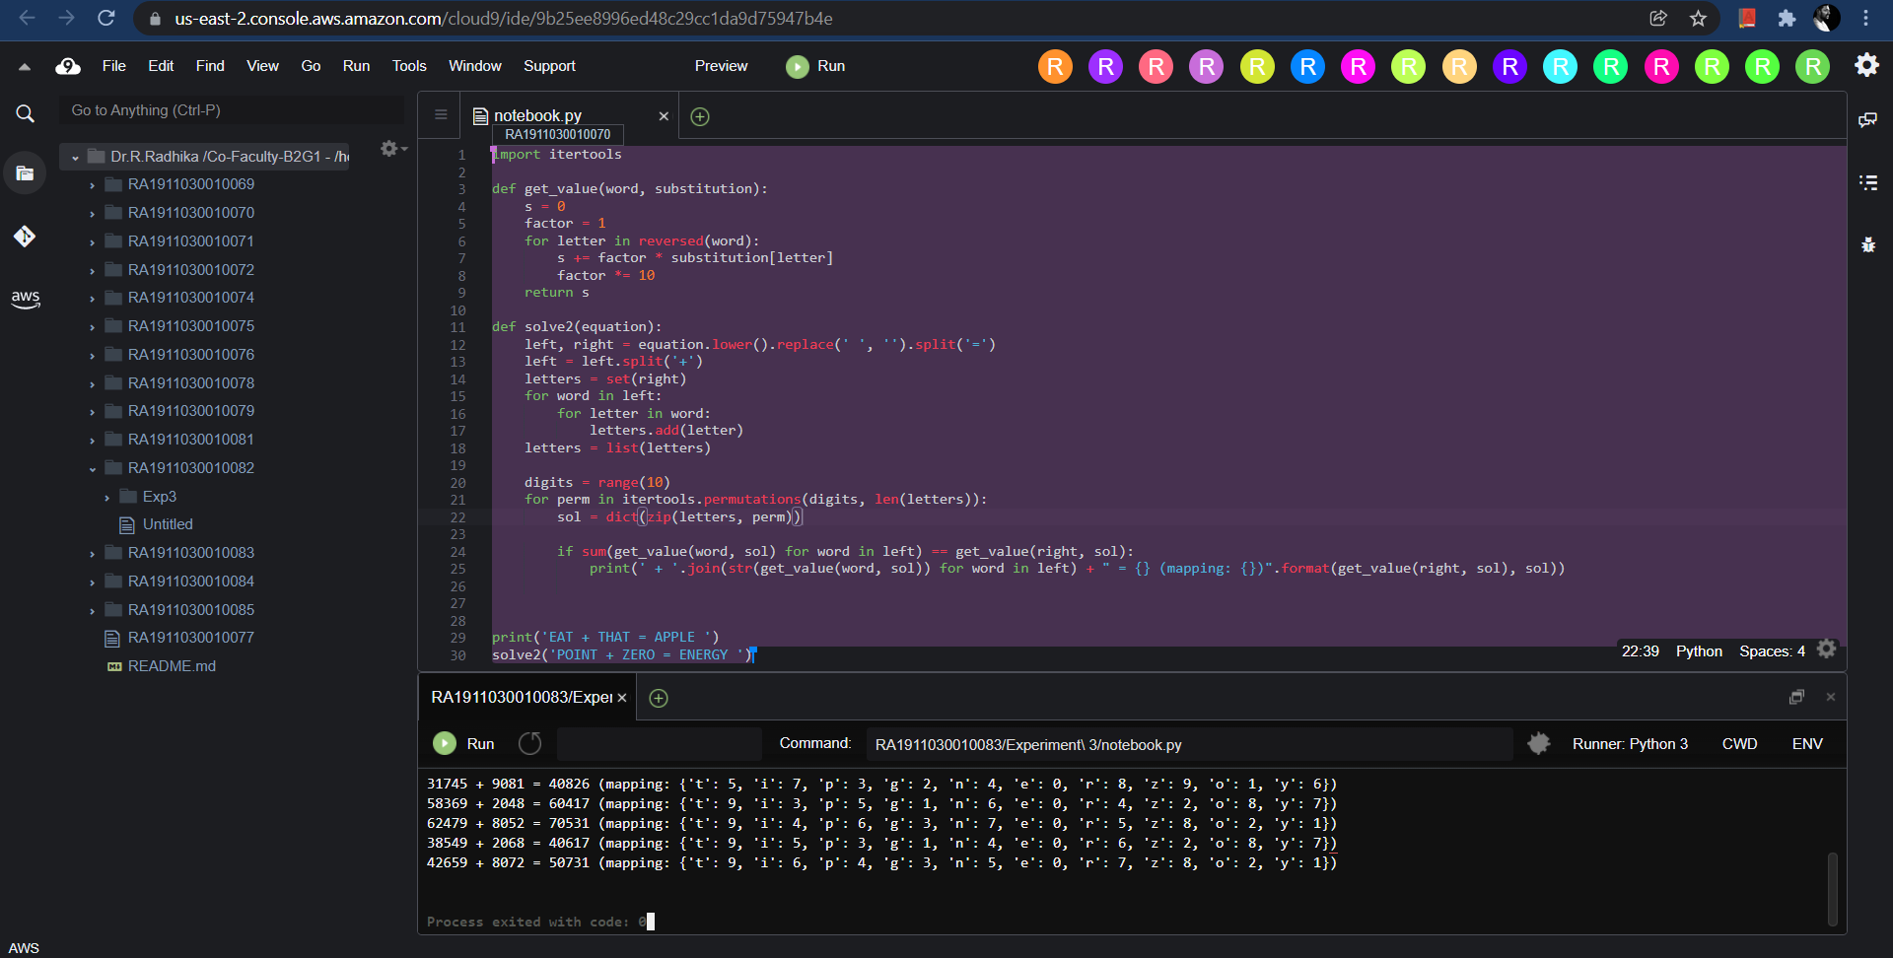

**Output:**

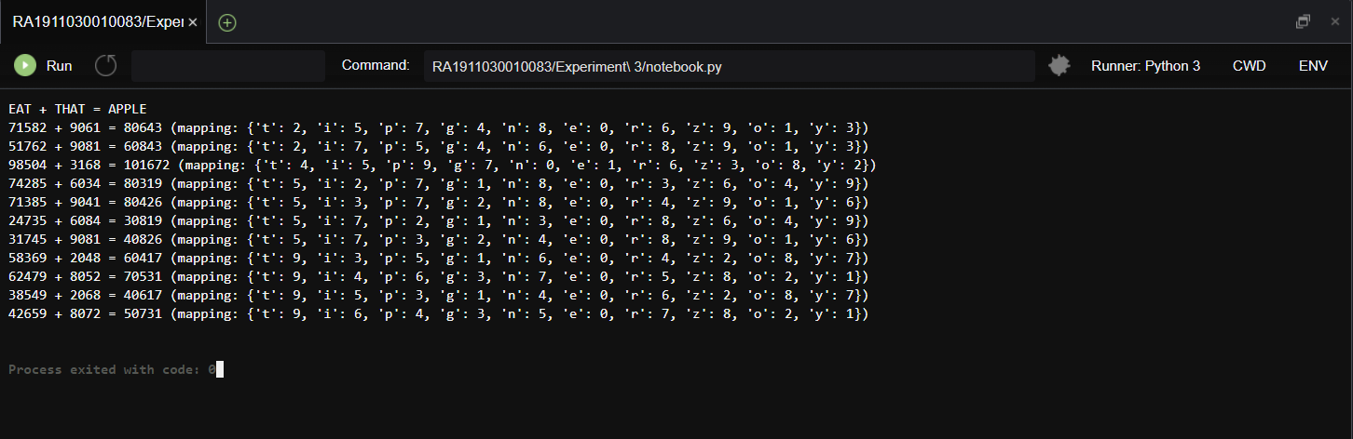

**Result:**

The constraint satisfying problem SEND + MORE = MONEY solved using the carry over technique and values for the alphabets obtained successfully.